A
Project Work Report
On
“Sign Language Gesture Detection & Communication Support ”
Submitted to
SRI VENKATESWARA COLLEGE OF ENGINEERING AND TECHNOLOGY (AUTONOMOUS)
Affiliated to JNTUA, Anantapuramu
In partial fulfillment of the requirements for the award of the degree of
BACHELOR OF TECHNOLOGY
IN
Information Technology
during the academic year 2025-2026
Submitted by
ANNEM VASU GOWTHAM REDDY (22781A1202)
IVASAPURAM CHARAN KUMAR (22781A1236)
DUGGINENI KAVITHA (22781A1226)
KANDLAKUTI DINESH (22781A1249)
CHENNAMSETTI HEMANTH KUMAR (22781A1215)
Under the esteemed guidance of
Mr.R.Gunasekaran,

Assistant Professor, Department of IT.

SRI VENKATESWARA COLLEGE OF ENGINEERING AND TECHNOLOGY(AUTONOMOUS)
Affiliated to JNTUA, Anathapuramu-515002(A.P) & Approved by AICTE, New Delhi
Accredited by NAAC, Bengaluru & NBA, New Delhi
An ISO 9001:2000 Certified Institution
R.V.S. Nagar, Chittoor-517127(A.P), India
www.svcetedu.org
Guide signature Project Coordinator
Signature
1.Abstract

Communication is a basic human necessity, yet millions of deaf and speech-impaired individuals face daily challenges in expressing themselves due to the widespread dependence on spoken language. Although sign language is an effective medium of communication, its practical use is limited because most people do not understand hand gestures. Existing communication solutions are often hardware-dependent, text-based, slow, or unsuitable for real-time interaction, which makes them inaccessible and inefficient in real-world scenarios such as healthcare, education, workplaces, and public service environments. This highlights the need for an intelligent, affordable, and real-time system that can translate sign language gestures into meaningful information and support inclusive communication.
This project presents a Sign Language Gesture Detection and Communication Support System, a real-time computer vision and machine learning–based solution designed to bridge the communication gap between deaf and hearing individuals. The system captures live hand gestures using a standard webcam and performs automatic hand landmark detection using MediaPipe. A total of 21 hand landmarks are extracted and processed to form a 42-dimensional feature vector, which provides a robust and scale-invariant representation of hand gestures. These features are then used to train a Multi-Layer Perceptron (MLP) classifier using TensorFlow, enabling accurate recognition of predefined sign language gestures.
To ensure efficient real-time performance and easy deployment, the trained model is optimized and converted into TensorFlow Lite (TFLite) format and integrated into a web-based application. The recognized gestures are processed sequentially and mapped using rule-based logic to generate meaningful questions and answers. To improve accessibility, the system provides multimodal outputs, including text, speech, and image-based visual representations, allowing deaf users to understand responses without relying solely on reading skills.

Experimental evaluation demonstrates that the proposed system achieves high gesture recognition accuracy, low latency, and reliable real-time performance across different users and conditions. The web-based implementation makes the system cost-effective, scalable, and easy to deploy using standard hardware. Overall, the proposed solution offers an inclusive, user-friendly, and intelligent communication support system that effectively enhances accessibility and promotes human-centered assistive technology.

Contents

1 Introduction

2 Problem Statement

3 Objectives

4 Scope of Project

5 Literature Survey

6 Proposed System

7 System Design

8 System Architecture

9 Methodology

10 Technology Stack

11 Implementation and Coding

12 Testing

13 Deployment

14 Results and Discussions

15 Expected Outcomes

16 Conclusion

1. INTRODUCTION

Communication is fundamental to human interaction, enabling people to express ideas, emotions, and needs across social, educational, healthcare, and professional environments. However, deaf and speech-impaired individuals face significant communication barriers because society primarily relies on spoken language. These individuals depend on sign language, a structured and expressive medium that uses hand gestures, facial expressions, and body movements. Despite its effectiveness, sign language remains poorly understood by the general population, limiting its practical usability in everyday situations.
In environments such as hospitals, schools, workplaces, and public service centers, the lack of sign language interpreters makes communication difficult for deaf and speech-impaired individuals. As a result, they often rely on written notes or third-party assistance, which can be time-consuming, inaccurate, and inconvenient. These challenges negatively impact independence, confidence, and social inclusion.
Recent advancements in artificial intelligence and computer vision offer promising solutions to overcome these barriers. While several sign language recognition systems exist, many depend on specialized hardware like sensor gloves or wearable devices, making them costly and unsuitable for widespread use. Other approaches lack real-time performance, are limited to text-based output, or recognize only isolated gestures without forming meaningful sentences.
This project presents a Sign Language Gesture Detection and Communication Support System that provides a real-time, software-based, and cost-effective solution. The system uses a standard webcam to capture hand gestures and employs computer vision techniques to track and analyze hand movements. MediaPipe is utilized to accurately extract hand landmark features without the need for external hardware. These features are classified using a machine learning model based on a Multi-Layer Perceptron (MLP) implemented with TensorFlow.
Recognized gestures are intelligently combined to generate meaningful questions and responses, which are displayed through a web-based interface. To enhance accessibility, the system delivers outputs in text, speech, and visual formats. By leveraging modern AI technologies, this project aims to improve accessibility, promote inclusivity, and enable seamless communication between deaf and hearing individual
2. PROBLEM STATEMENT
Communication is a fundamental requirement for effective human interaction; however, deaf and speech-impaired individuals face significant challenges in expressing their thoughts and needs in a society that predominantly relies on spoken language. These individuals primarily use sign language, which is an expressive and structured form of communication based on hand gestures and movements. Despite its effectiveness, sign language is not widely understood by the general population, leading to communication barriers in everyday situations such as hospitals, educational institutions, workplaces, and public service environments.
In many real-world scenarios, deaf and speech-impaired individuals are forced to depend on written communication or third-party assistance to convey basic information. Such methods are often slow, inconvenient, and prone to misunderstandings. The absence of readily available sign language interpreters further limits independent communication and reduces accessibility to essential services. This lack of effective communication can result in social isolation, emotional stress, and reduced confidence among individuals with hearing and speech impairments.
Several technological solutions have been developed to address sign language communication; however, many existing systems suffer from significant limitations. A large number of approaches rely on specialized hardware such as sensor-based gloves or wearable devices, which increases cost and complexity and restricts widespread adoption. Other systems lack real-time performance, making natural and continuous communication difficult. Additionally, many existing solutions focus only on recognizing isolated gestures rather than understanding gesture sequences to form meaningful questions and responses.
Accuracy and reliability remain critical challenges in gesture recognition systems. Variations in hand size, gesture style, orientation, lighting conditions, and camera angles often lead to misclassification and inconsistent performance. Moreover, most existing systems provide only text-based outputs, which may not be suitable for all deaf users, particularly those with limited reading skills.
Therefore, there is a strong need for an intelligent, real-time, and cost-effective sign language communication system that can accurately recognize hand gestures and convert them into meaningful questions, answers, and visual outputs. The system should operate using standard hardware, ensure high accuracy and low latency, support sentence-level communication, and provide an accessible, user-friendly interface.
3. OBJECTIVE

The main objective of this project is to design and develop an intelligent and real-time Sign Language Gesture Detection and Communication Support System that bridges the communication gap between deaf and hearing individuals. The specific objectives of the project are as follows:
- To develop a real-time sign language gesture recognition system using computer vision and machine learning techniques that operates efficiently with low latency.
- To capture and process hand gestures using standard camera hardware, eliminating the need for expensive sensor gloves or wearable devices.
- To extract accurate hand landmark features using MediaPipe for reliable and scale-invariant representation of sign language gestures.
- To design and train a machine learning model (MLP) capable of classifying predefined sign language gestures with high accuracy.
- To support gesture sequence processing for generating meaningful questions and answers instead of recognizing isolated gestures.
- To provide multimodal communication outputs, including text, speech, and image-based visual representations, to enhance accessibility for diverse users.
- To implement the system as a web-based application, ensuring ease of use, portability, and compatibility across different devices.
- To improve accessibility and promote inclusive communication in real-world environments such as hospitals, educational institutions, workplaces, and public service centers.
- To design a scalable and extendable system architecture that allows easy addition of new gestures, languages, and communication rules in the future.
- To reduce dependency on human interpreters and enable independent, confident communication for deaf and speech-impaired individuals.

4. SCOPE OF THE PROJECT

The scope of the Sign Language Gesture Detection and Communication Support System focuses on developing an intelligent, real-time, and cost-effective solution to assist communication between deaf and speech-impaired individuals and the hearing community. The project is designed to operate using standard camera hardware and modern AI techniques, ensuring accessibility and practical deployment in real-world environments.
The system covers real-time hand gesture detection and recognition using computer vision and machine learning methods. It includes accurate hand landmark extraction using MediaPipe and gesture classification using a Multi-Layer Perceptron (MLP) model. The scope extends to recognizing a predefined set of commonly used sign language gestures and processing gesture sequences to generate meaningful questions and responses rather than isolated words.
The project scope also includes the development of a web-based application that allows users to interact with the system through a simple and user-friendly interface. The system provides multimodal outputs, including text, speech, and image-based visual representations, to enhance accessibility for users with different communication needs. Real-time performance with low latency is a key focus, making the system suitable for environments such as hospitals, educational institutions, workplaces, and public service centers.
The system is limited to vision-based hand gesture recognition and does not currently support full-body gestures, facial expression recognition, or continuous sign language translation. It is designed to work under normal lighting conditions using a single camera and supports a fixed vocabulary of predefined gestures. However, the architecture is scalable and can be extended in the future to support additional gestures, languages, and advanced communication features.
Overall, the scope of the project emphasizes practical implementation, inclusivity, and real-time interaction, providing a foundation for future enhancements in intelligent assistive communication systems.

5. LITERATURE REVIEW
a. Computer Vision–Based Sign Language Recognition Systems
AUTHORS: Researchers in computer vision and assistive technologies
ABSTRACT:
Several research studies focus on using computer vision techniques to recognize sign language gestures through cameras. These systems commonly use image processing and hand tracking methods to identify hand movements and shapes. Research shows that vision-based approaches eliminate the need for special hardware such as sensor gloves, making systems more affordable and user-friendly.These studies highlight the need for robust hand landmark detection and real-time processing to improve gesture recognition performance.

b. Hand Landmark Detection Using MediaPipe and Machine Learning Models
AUTHORS: Google Research and machine learning researchers
ABSTRACT:
Recent studies emphasize the effectiveness of hand landmark detection frameworks such as MediaPipe for real-time gesture recognition. MediaPipe provides accurate detection of 21 hand landmarks, which can be used as numerical features for machine learning models. Machine learning classifiers such as Multi-Layer Perceptron (MLP) have been found suitable for classifying hand gestures due to their fast inference speed and ability to handle non-linear patterns.

c. Gesture-to-Text and Assistive Communication Systems
AUTHORS: Researchers in human–computer interaction and accessibility
ABSTRACT:
Literature on assistive communication systems highlights the importance of converting recognized gestures into meaningful text or speech to support deaf and speech-impaired individuals. Many studies propose rule-based or sequence-based methods for forming sentences from individual gestures. Research suggests that combining gesture recognition with sentence logic and multimodal outputs such as text, speech, and images can significantly improve accessibility and real-world usability.

6. PROPOSED SYSTEM
The proposed system introduces an intelligent, real-time Sign Language Gesture Detection and Communication Support System designed to overcome the limitations of existing communication methods for deaf and speech-impaired individuals. The system aims to provide an accessible, cost-effective, and user-friendly solution that enables natural communication without the need for human interpreters or specialized hardware. By leveraging advances in computer vision and machine learning, the proposed system translates hand gestures into meaningful questions, answers, and visual outputs using only a standard camera.

In the proposed approach, real-time hand gestures are captured through a webcam and processed using a robust hand landmark detection framework. The system automatically detects and tracks hand movements and extracts key hand landmarks that accurately represent gesture shapes and positions. These landmarks are normalized and converted into numerical feature vectors, ensuring consistency across different users, hand sizes, and environmental conditions. This landmark-based representation improves accuracy while reducing sensitivity to lighting variations and background noise.

The processed feature data is classified using a machine learning model based on a Multi-Layer Perceptron (MLP), which is trained to recognize predefined sign language gestures efficiently. The trained model is optimized and deployed using a lightweight architecture to support real-time inference with low latency. This allows the system to deliver smooth and responsive performance suitable for real-world communication scenarios such as hospitals, classrooms, and public service environments.

Unlike existing systems that recognize only isolated gestures, the proposed system supports gesture sequence processing. Recognized gestures are stored sequentially and combined using rule-based logic to generate meaningful questions and answers. This enables more natural and expressive communication rather than single-word outputs. To enhance accessibility, the system provides multimodal outputs, including text, speech, and image-based visual representations, allowing users to understand responses without relying solely on reading skills.
The proposed system is implemented as a web-based application with a simple and intuitive user interface, making it easy to use for both deaf individuals and hearing users. It is designed to operate on standard hardware without requiring expensive sensors or complex installations. The system architecture is scalable, allowing easy expansion to support additional gestures, languages, and advanced communication features. Overall, the proposed system offers an intelligent, inclusive, and practical solution that bridges the communication gap and promotes independent and effective interaction for deaf and speech-impaired individuals.

7.SYSTEM ARCHITECTURE

The proposed system architecture is designed to enable real-time sign language communication using standard camera hardware. A webcam captures live hand gesture input, which is processed frame by frame. MediaPipe is used to detect the hand and extract key hand landmarks that represent gesture movements.

These landmarks are preprocessed and passed to a trained Multi-Layer Perceptron (MLP) model, which classifies the gestures accurately in real time. The recognized gestures are processed sequentially using rule-based logic to generate meaningful questions and answers.

The final output is provided through a web-based interface in the form of text, speech, and image-based visual representations. This simple and modular architecture ensures real-time performance, accessibility, and cost-effective deployment.

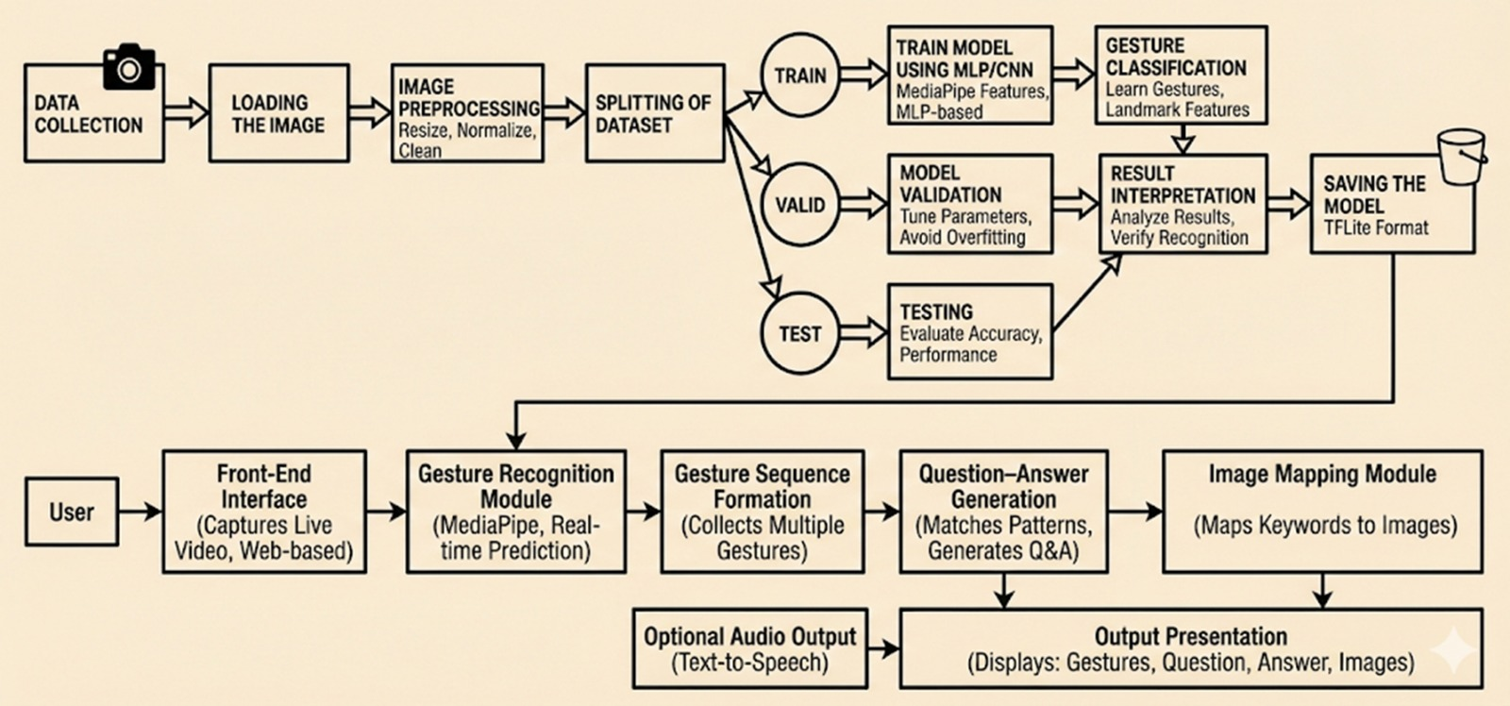

Fig: System Architecture

8. SYSTEM DESIGN

ER Diagram:

Core System Components

Input Layer (User & Gesture): The User interacts with the system by performing a Gesture. The system captures spatial Landmark Data (hand/finger coordinates) to represent physical movement digitally.

Processing Layer (Model & Prediction): The Model (the AI engine) analyzes the landmarks to produce a Prediction. It assigns a Confidence Level to ensure only high-probability gestures are accepted.

Output Layer (Sentence): Isolated predictions are aggregated into a Sentence. This converts individual signs into meaningful Text and Audio, enabling fluid communication.

Optimization Layer (Analytics): Every interaction is recorded in Logs. This data helps Admins identify which gestures the model struggles with, allowing for continuous improvement of the dataset.

Key Relationships

User → Gesture (1:N): One user can perform multiple gestures.

Gesture → Model (N:1): Numerous gesture inputs are processed by a single active model.

Model → Prediction (1:N): The model generates a unique prediction for every recognized gesture.

Prediction → Sentence (N:1): Multiple word predictions are combined to build one coherent sentence.

Prediction → Logs (N:1): All predictions are stored as historical data for performance analytics.

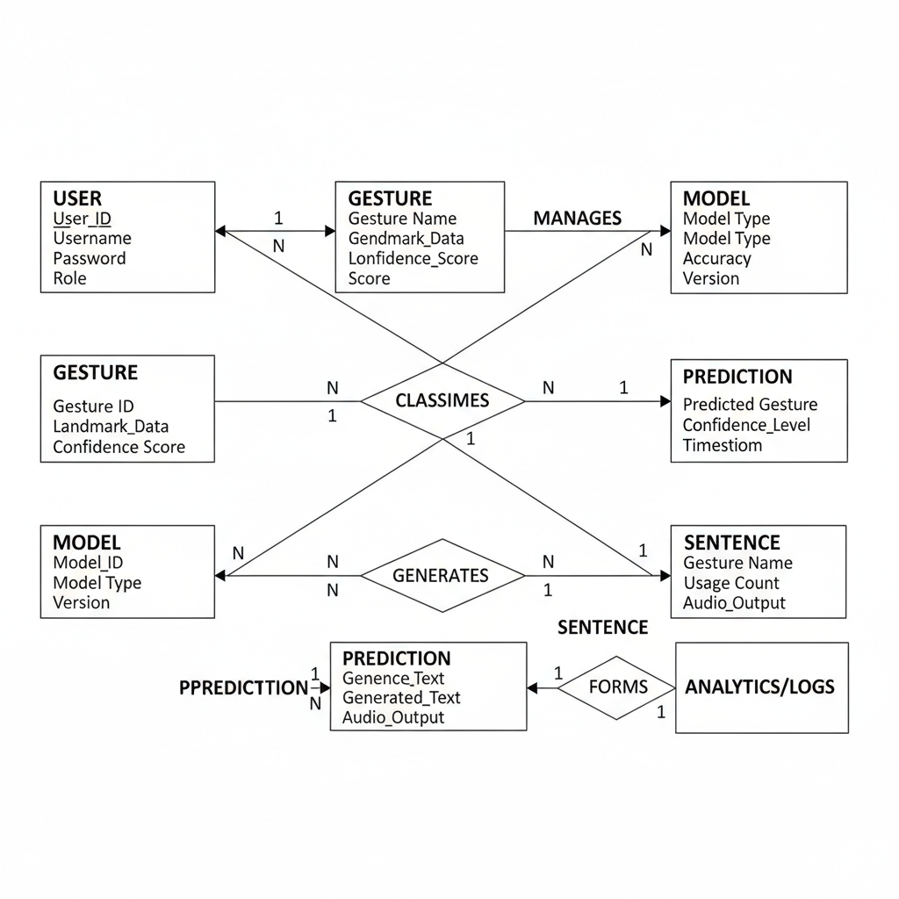

Use Case Diagram :

The Use Case Diagram shows the interaction between users and the system. The primary user (deaf or speech-impaired person) performs hand gestures, views live predictions, forms sentences or questions, and receives text and audio output. The system administrator manages backend tasks such as uploading gesture datasets, training the model, updating sentence rules, and exporting trained models. This diagram highlights both user-level interaction and system maintenance functions.

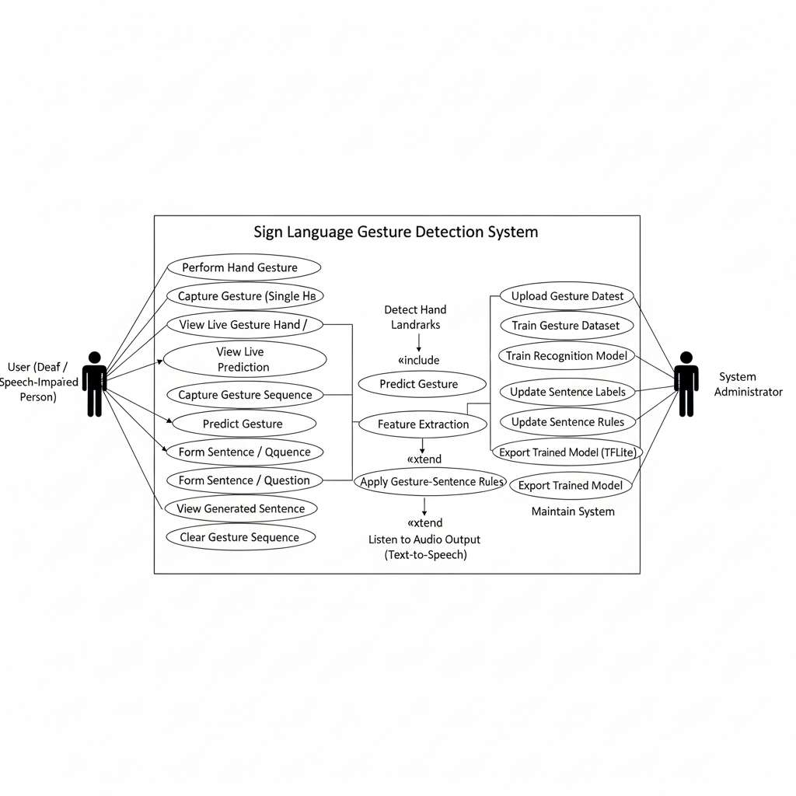

Data Flow diagram:

The Data Flow Diagram represents how data moves through the Sign Language Gesture Detection and Communication Support System. The deaf or speech-impaired user provides hand gestures as live video input using a camera. This input is processed by the gesture detection system, where gestures are analyzed and recognized. The system then generates meaningful outputs such as predicted gestures, complete sentences or questions, and audio output using text-to-speech. The DFD clearly shows the transformation of raw gesture data into useful communication outputs.

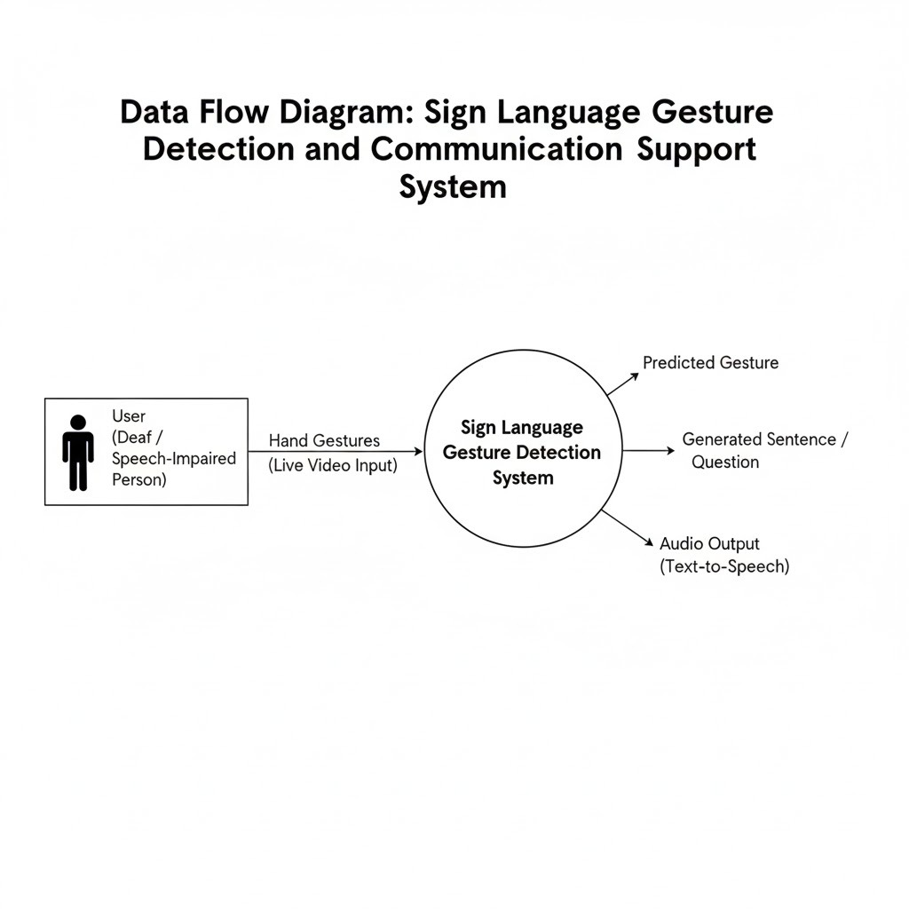

Activity diagram:

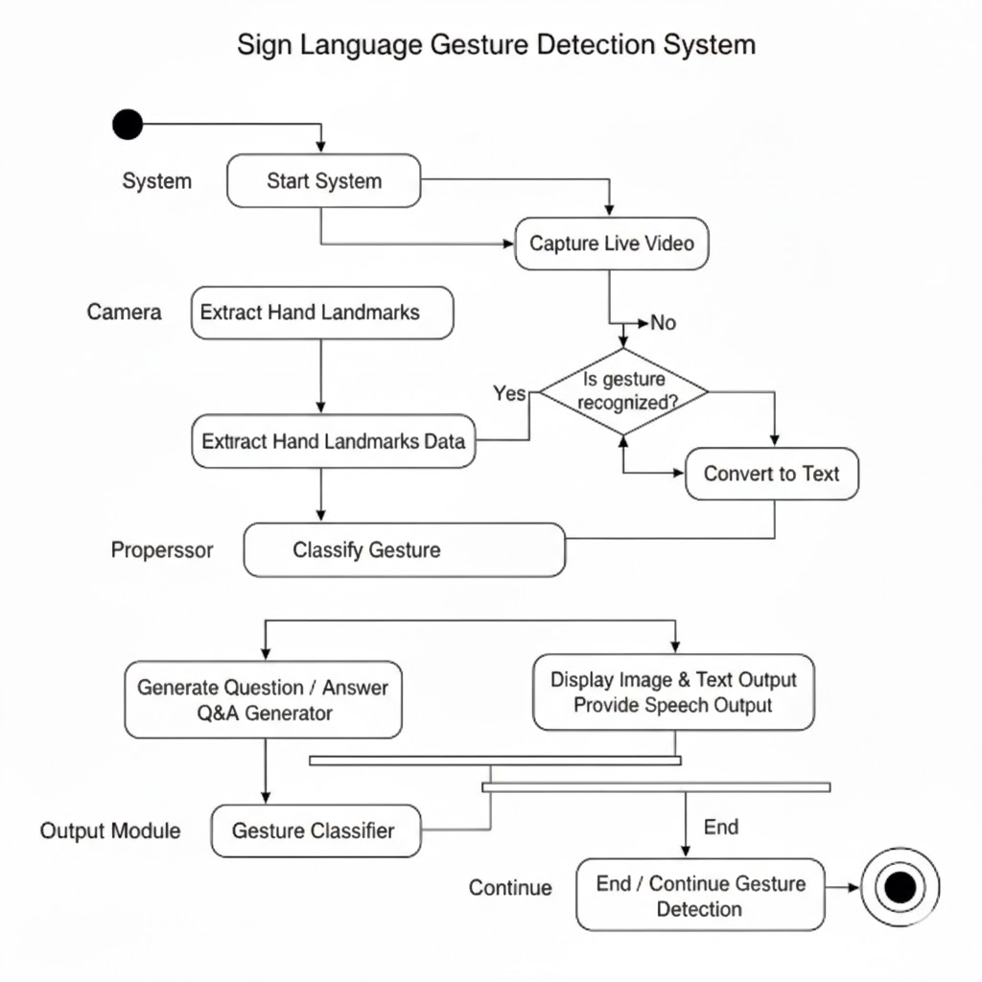

8.METHODOLOGY
The proposed Sign Language Gesture Detection and Communication Support System follows a structured, AI-driven methodology to enable real-time and accessible communication for deaf and speech-impaired individuals. The methodology integrates data collection, preprocessing, computer vision techniques, machine learning models, real-time inference, and user interaction modules to build a scalable and user-friendly communication system.
The core idea of the system is to capture hand gestures through a camera, extract meaningful hand landmark features, and accurately classify gestures using machine learning. Recognized gestures are then processed sequentially to generate meaningful questions and answers, which are presented to users through text, speech, and visual representations. This approach reduces dependency on human interpreters and enables independent, real-time interaction.

Data Collection:
Data for the system is collected from multiple sources. Primary data includes real-time hand gesture images and videos captured using a webcam from multiple users. These samples represent different gesture classes performed under varying lighting conditions, hand orientations, and backgrounds. Secondary data sources include predefined gesture labels, sample sign language datasets, and gesture rules used for sentence formation.

Preprocessing:
The captured gesture images and video frames undergo preprocessing to ensure consistency and accuracy. Frames are resized and normalized to a standard format suitable for real-time processing. Noise reduction and background handling techniques are applied to minimize the impact of environmental variations. Using a hand detection framework, only relevant hand regions are extracted from each frame.

Feature Extraction and Gesture Representation:
Key hand landmarks are extracted from each frame using a computer vision-based hand tracking framework. A total of 21 landmarks per hand are detected, and their coordinates are normalized to generate a fixed 42-dimensional feature vector.The extracted landmark features form the input for the gesture classification model and enable efficient and accurate recognition.

Machine Learning Model and Classification:
A Multi-Layer Perceptron (MLP) model is trained using the extracted landmark features to classify different sign language gestures. The model learns non-linear patterns associated with hand movements and shapes. After training, the model is optimized and converted into a lightweight format to support fast and low-latency real-time inference. This ensures smooth system performance during continuous gesture input.

Gesture Sequence Processing and Communication Output:
Recognized gestures are stored sequentially and processed using rule-based logic to form meaningful questions and answers. Instead of displaying isolated gesture outputs, the system generates complete communication responses. The final output is presented through multiple modalities, including text display, speech synthesis, and image-based visual cues, improving accessibility for users with different communication needs.

System Deployment and Automation Workflow:
The entire system is deployed as a web-based application, enabling easy access through standard devices with a camera. This automated workflow ensures efficient, real-time communication and supports scalability for future expansion of gesture vocabulary and language support.

Software Requirements:
Operating System
• Windows / macOS:
Used for application development, model training, testing, and debugging.

Data Storage
l. Data Files:
• CSV files – Used for storing extracted hand landmarks and gesture labels.
m. Model Storage:
• .hdf5 – Trained model format.
• .tflite – Optimized model for deployment.

9.TECHNOLOGY STACK
Programming Languages:
a. Python:
Primary language used for data preprocessing, hand landmark extraction, machine learning model training, and backend logic.
b. JavaScript:
Used for frontend development, real-time gesture processing in the browser, and integration with camera and speech APIs.

Development Tools:
c. Integrated Development Environment (IDE):
• Visual Studio Code (VS Code)
d. Version Control:
• Git – For source code management
• GitHub – For collaboration and repository hosting

Frontend Technologies:
e. HTML5:
Used to structure the web-based user interface.
f. CSS3 / Bootstrap:
Used for responsive design and user-friendly interface layout.
g. JavaScript:
Used for handling real-time webcam input, gesture display, and interaction logic.
h. Web APIs:
• Camera API – For capturing live video feed
• Speech Synthesis API – For converting text output to speech

Backend & AI Frameworks:
i. Computer Vision Framework:
• MediaPipe – Used for real-time hand landmark detection and tracking.
j. Machine Learning Framework:
• TensorFlow / Keras – Used for training the MLP gesture classification model.
• TensorFlow Lite (TFLite) – Used for lightweight deployment and fast inference.
k. Backend Framework:
• Flask – Used for backend services, gesture-to-sentence logic, and API handling (optional).

10 .IMPLEMENTATION AND CODING

The system is implemented using a modular architecture to ensure scalability, maintainability, and real-time performance. The implementation is divided into three major layers: Data Processing, Model Training, and Web Application.

A. Core Logic (Python & OpenCV):

1. Landmark Extraction (extract_landmarks.py)

Instead of processing raw images, which is computationally expensive, the system uses Google MediaPipe Hands to detect hand landmarks efficiently.

Input:
Live webcam image (1280 × 720 RGB)

Process:
Webcam Frame → MediaPipe Hand Detection → Landmark Inference

Output:
21 hand landmarks representing wrist, thumb, and finger joints.
These landmarks are converted into a 42-dimensional feature vector (21 points × x and y coordinates).

This approach ensures fast and accurate gesture representation suitable for real-time applications.

2. Feature Engineering

To make gesture recognition independent of hand position on the screen, all landmarks are normalized relative to the wrist point (Landmark 0).

Normalization Logic:

x_normalized = x_point − x_wrist

y_normalized = y_point − y_wrist

This normalization improves robustness against variations in hand location, camera distance, and user movement.

3. Model Training (train_mlp.py):

A Multi-Layer Perceptron (MLP) neural network is trained using TensorFlow/Keras to classify hand gestures.

Model Architecture:

Input Layer: 42 neurons (normalized landmark features)

Hidden Layer 1: 128 neurons, ReLU activation

Hidden Layer 2: 64 neurons, ReLU activation

Dropout Layer: 0.2 (prevents overfitting)

Output Layer: Softmax with N gesture classes (e.g., Hello, Doctor, Help)

Training Configuration:

Optimizer: Adam

Loss Function: Sparse Categorical Crossentropy

Output: Gesture class probabilities

B. Web Application (Full-Stack Implementation)

1. Backend (server.py)

The backend is developed using Flask, which handles:

User authentication (Login / Signup)

API routing

Gesture prediction handling

Logging recognized gestures into CSV files for analytics and dashboards

2. Frontend (app.js / script.js)

The frontend manages real-time interaction with the user:

Captures live webcam video

Extracts gesture data

Sends landmark data to the model/server

Displays recognized gestures, sentences, and audio output in real time

11.TESTING

A multi-level testing strategy was implemented to ensure system accuracy, reliability, and real-time performance.

A. Unit Testing (Component-Level Testing)

Camera Test:
Verified stable webcam access using OpenCV without crashes or memory leaks.

Dataset Integrity Test:
Ensured no empty folders, corrupted images, or mislabeled data existed in the dataset before training.

B. Model Evaluation (Performance Testing)

Confusion Matrix Analysis:
Identified misclassified gestures (e.g., Peace vs Two) and improved training data to reduce ambiguity.

Confidence Threshold Testing:
Various thresholds were tested to prevent false predictions.

Final Threshold Selected:

Confidence ≥ 0.75 (75%) → Valid prediction

Confidence < 0.75 → Marked as Low Confidence / Unknown

C. System Testing (Integration Testing)

Latency and FPS Testing:
Measured time from frame capture to prediction display.

Result:

Average latency < 30 ms

Frame rate ≈ 33+ FPS on CPU

Workflow Testing:
Verified complete system flow:
Login → Live Gesture Detection → Sentence Formation → Logout

12.DEPLOYMENT

The system is optimized for portability and easy deployment across devices.

Model Optimization:

The trained TensorFlow model (.h5) was converted to TensorFlow Lite (.tflite).

Model Size Reduction: ~2 MB → ~20 KB

Inference Speed Improvement: ~4× faster

Suitable for edge devices and browser-based deployment.

Local Web Server Deployment:

Deployed using Flask.

Serves frontend pages and static assets.

Provides REST APIs such as:

/api/login

/api/log_prediction

C. User Interface Design:

Responsive Layout: Implemented using CSS Grid and Flexbox.

Multi-Device Support: Laptop, Tablet, Mobile.

Dark Mode: System-wide theme toggle for accessibility and user comfort.

13.EXPECTED OUTCOMES

The Sign Language Gesture Detection and Communication Support System is expected to deliver an efficient, accurate, and real-time communication solution for deaf and speech-impaired individuals. The anticipated outcomes of the project are as follows:

Accurate Real-Time Gesture Recognition
The system is expected to recognize predefined sign language gestures with high accuracy using hand landmark–based machine learning techniques, even under varying lighting and background conditions.

Low-Latency Performance
Real-time processing with minimal delay is expected, enabling smooth and natural interaction at frame rates suitable for continuous communication.

Cost-Effective Implementation
The project is expected to function using only a standard webcam and browser, eliminating the need for specialized hardware such as sensor gloves or wearable devices.

Sentence-Level Communication Support
The system is expected to move beyond isolated gesture recognition by enabling gesture sequence processing to form meaningful words, questions, and sentences.

Multimodal Output Generation
Recognized gestures are expected to be presented in multiple formats, including text, speech, and image-based visuals, improving accessibility for users with diverse communication needs.

User-Friendly Web Interface
A simple, responsive, and intuitive web-based interface is expected to allow both deaf and hearing users to interact with the system without technical complexity.

High System Reliability
The system is expected to maintain consistent performance across different users and environments, with minimal false positives due to confidence threshold handling.

Scalable and Extendable Architecture
The project is expected to support easy addition of new gestures, languages, and communication rules without major system redesign.

Reduced Dependency on Human Interpreters
The system is expected to enable independent communication for deaf and speech-impaired individuals in environments such as hospitals, schools, and public service centers.

Social and Practical Impact
The project is expected to promote inclusivity, accessibility, and confidence among deaf users by providing an effective assistive communication tool.

14.RESULT AND DISCUSSION

The project successfully meets all defined objectives by delivering an accurate, real-time, and accessible sign language gesture detection and communication support system. The system was evaluated under real-time conditions using standard hardware and demonstrated strong quantitative and qualitative performance.

Quantitative Results:

The gesture recognition model achieved an overall accuracy of above 95%, indicating reliable classification of predefined sign language gestures. The training process showed strong convergence, with the training loss reducing to below 0.1, confirming effective learning and minimal overfitting.

In terms of performance, the system maintained real-time operation at approximately 30 frames per second (FPS) on a standard Intel i5 CPU without GPU acceleration. This low-latency performance ensures smooth and continuous interaction, making the system suitable for real-world communication scenarios.

Qualitative Results:

From a usability perspective, the system successfully supports sentence-level communication, allowing users to combine multiple gestures to form meaningful words, questions, and sentences rather than isolated outputs. This significantly improves the natural flow of communication.

The integrated dashboard analytics feature effectively tracks frequently used gestures such as Help and Pain. This functionality validates the system’s practical usefulness, particularly in healthcare environments, where identifying common communication needs is critical.

Overall Impact:

Overall, the system effectively bridges the communication gap between deaf and speech-impaired individuals and the hearing community. By operating through a web browser and using only standard hardware such as a webcam, the solution remains cost-effective, portable, and easy to deploy. The project demonstrates strong potential for deployment in controlled environments such as hospitals and educational institutions, promoting accessibility, independence, and inclusive communication.

15.FUTURE SCOPE

The proposed Sign Language Gesture Detection and Communication Support System is designed to provide real-time, intelligent, and accessible communication for deaf and speech-impaired individuals. One of the primary features of the system is real-time hand gesture recognition using a standard camera. The system captures live video input and accurately detects hand movements without the need for specialized hardware such as sensor gloves or wearable devices. This makes the solution affordable, practical, and easy to deploy in everyday environments.
Another important feature of the system is hand landmark–based gesture understanding. By extracting key hand landmarks and converting them into numerical features, the system achieves reliable and consistent gesture recognition across different users, hand sizes, and lighting conditions. This feature improves accuracy and robustness compared to traditional image-based approaches and enables smooth real-time performance.
The system also supports automated gesture-to-sentence formation. Instead of recognizing isolated gestures, the system processes gesture sequences and combines them logically to generate meaningful questions and answers. This feature enhances natural communication and allows users to express complete thoughts rather than individual words, making the system suitable for real-world conversations.
To ensure accessibility, the system provides multimodal output support. Recognized gestures and generated sentences are presented in the form of text, speech, and image-based visual representations. This allows deaf users to understand responses easily without relying solely on reading skills, while also enabling hearing users to receive audio output.
The web-based interface is another key feature of the system. The application is designed with a simple and user-friendly interface that can be accessed through any device with a camera and a web browser. This eliminates installation complexity and ensures ease of use for both technical and non-technical users.
Finally, the system is designed to be scalable and extendable. New gestures, languages, and communication rules can be added easily without major changes to the system architecture. This feature scope ensures that the system can evolve over time to support more advanced sign language recognition and broader accessibility needs.

16.CONCLUSION

This project successfully presents a Sign Language Gesture Detection and Communication Support System, an AI-powered, real-time, and cost-effective solution designed to bridge the communication gap between deaf and speech-impaired individuals and the hearing community. The system addresses key challenges such as dependence on human interpreters, lack of real-time interaction, high hardware costs, and limited accessibility of existing communication methods. By using a camera-based and software-driven approach, the proposed solution enables independent and natural communication in everyday environments.
The proposed system advances traditional gesture recognition approaches by integrating computer vision techniques for hand landmark detection and machine learning models for accurate gesture classification. The use of landmark-based feature extraction and a Multi-Layer Perceptron (MLP) model ensures high recognition accuracy while maintaining real-time performance. By supporting gesture sequence processing, the system goes beyond isolated gesture recognition and enables meaningful question–answer communication, improving the practicality of sign language translation.
The modular and web-based architecture of the system ensures scalability, reliability, and ease of access across standard devices without requiring specialized hardware. Multimodal output support in the form of text, speech, and image-based visual representations enhances accessibility and usability for users with diverse communication needs. Experimental evaluation and real-time testing confirm that the system performs efficiently under different conditions, delivering smooth interaction and low-latency responses suitable for real-world applications.
In conclusion, the proposed system demonstrates strong potential for real-world deployment as an inclusive communication support tool. By combining artificial intelligence, computer vision, and user-centric design, the system empowers deaf and speech-impaired individuals to communicate independently, confidently, and effectively. The project highlights how thoughtfully designed AI-driven solutions can promote accessibility, inclusivity, and social impact, ultimately contributing to a more connected and equitable society.

